AWS Project: IAM Role & Policy Management
1. Introduction
AWS Identity and Access Management (IAM) is a security service that allows you to control who can access AWS resources and what actions they can perform. IAM enables administrators to create users, groups, roles, and policies to manage permissions securely.
In this project, we implement IAM Role and Policy Management to enforce the Principle of Least Privilege, ensuring that users and services only get the permissions they actually need.
The project demonstrates how to:
- Create IAM Users
- Create Custom IAM Policies
- Create IAM Roles
- Attach Roles to an EC2 Instance
- Verify access using S3 commands
Services Used:
- AWS Identity and Access Management
- Amazon EC2
- Amazon S3

2. Architecture Overview
User → IAM Policy → IAM Role → EC2 Instance → Access S3 Bucket
Flow:
- IAM User is created to manage AWS resources.
- Custom policy defines permissions.
- IAM Role is created with that policy.
- Role is attached to EC2 instance.
- EC2 instance accesses S3 bucket securely.

3. Implementation Steps
Step 1: Create an IAM User
- Login to AWS Management Console.
- Go to IAM Service.
- Click Users → Add Users.
- Enter username : devops
- Select access type:
  - ✔ Programmatic Access (CLI/API)
- Click Next: Permissions.
- Select Attach policies directly.
- Attach policy : AdministratorAccess
- Click Next → Review → Create User.
- Download: Access Key ID ,Secret Access Key

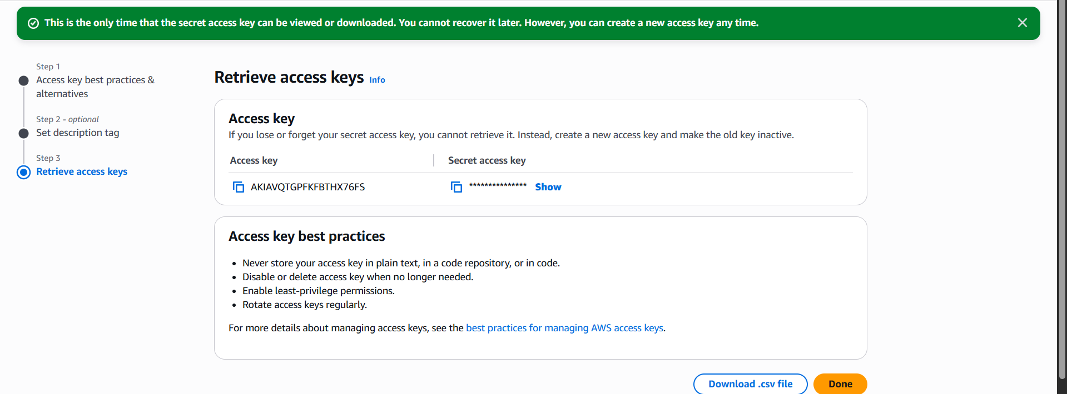

Step 2: Create a Custom IAM Policy
- Go to IAM → Policies.
- Click Create Policy.
- Select JSON.
Example Policy (S3 Read Only):
{
"Version": "2012-10-17",
"Statement": [
{
"Effect": "Allow",
"Action": "s3:ListBucket",
"Resource": "arn:aws:s3:::example-bucket"
},
{
"Effect": "Allow",
"Action": "s3:GetObject",
"Resource": "arn:aws:s3:::example-bucket/*"
}
]
}
- Click Next.
- Name the policy:
S3ReadOnlyPolicy
- Click Create Policy.

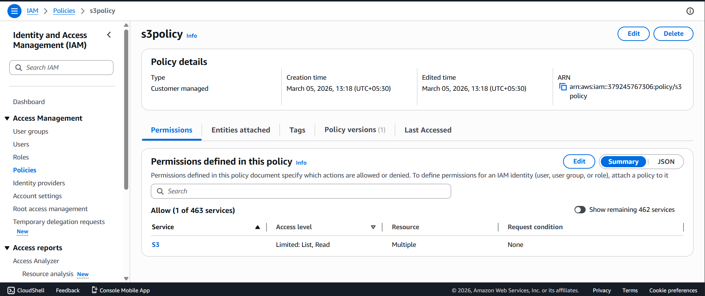

Step 4: Attach IAM Role to EC2 Instance
- Go to EC2 Console.
- Select your instance.
- Click:
Actions → Security → Modify IAM Role
- Choose role:
S3ReadOnlyRole
- Click Update IAM Role.
Now the EC2 instance will automatically get S3 permissions.


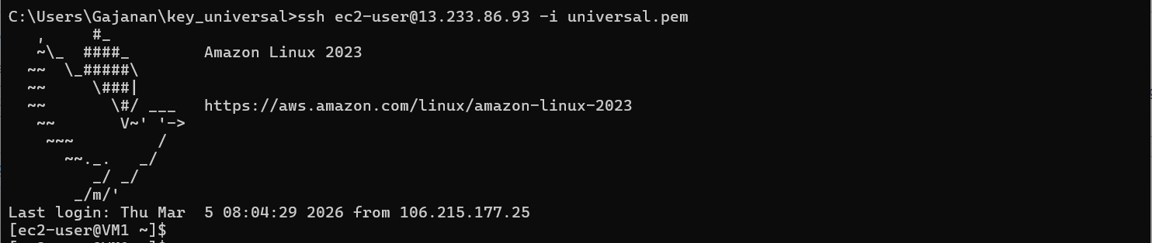

Step 5: Verify IAM Role Access
SSH into EC2 instance.
Install AWS CLI if not installed:
sudo yum install aws-cli -y
Check S3 bucket access:
aws s3 ls s3://example-bucket
If the role is working:
✔ Bucket contents will be displayed.

Test Restricted Access
Try deleting a file:
aws s3 rm s3://example-bucket/test.txt
Result : AccessDenied / No
This confirms least privilege security is working.
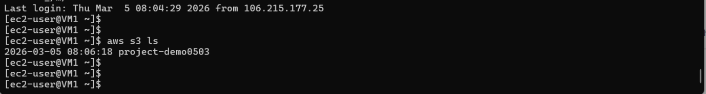

4. Security Best Practices
✔ Use IAM Roles instead of Access Keys for EC2.
✔ Follow Least Privilege Principle.
✔ Rotate credentials regularly.
✔ Avoid using root account for daily tasks.
✔ Enable MFA for IAM users.

5. Project Outcome
After completing this project you will understand:
- IAM Users
- IAM Policies
- IAM Roles
- Role-based access to AWS services
- Secure resource management

6. Conclusion
This project demonstrated how to implement secure access control using IAM roles and policies. By attaching an IAM role with a restricted policy to an EC2 instance, we enabled the instance to access an S3 bucket without using static credentials.
This approach improves security, scalability, and compliance by following AWS best practices such as role-based access control and least privilege.

